2, Write a C program to find Odd or Even number from a given set of numbers

Program:

#include <stdio.h>

int main() {

int num;

printf("Enter an integer: ");

scanf("%d", &num);

if(num % 2 == 0)

printf("%d is an even number.", num);

else

printf("%d is an odd number.", num);

return 0;

}

Input:

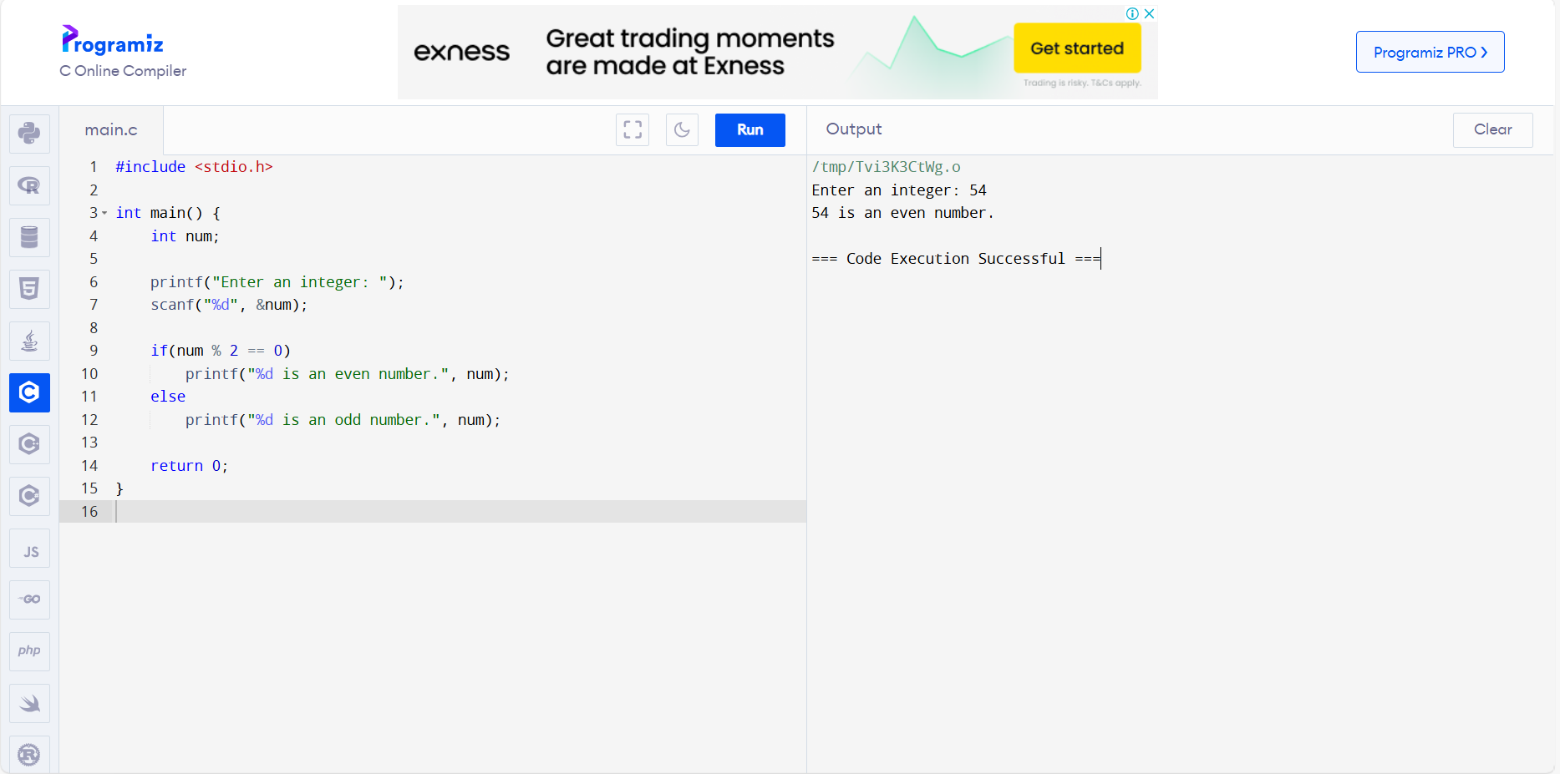

Output:

